**DBMS LAB RECORD**

**VAKAMALLA KEERTHIPRIYA**

**(1BM19CS176)**

**LAB1-INSURANCE DATABASE**

create database insurance;

use insurance;

create table person(driver_id varchar(5),name varchar(10),address varchar(20),primary key (driver_id));

desc person;

create table car(reg_num varchar(10),model varchar(10),year int,primary key(reg_num));

desc car;

create table accident(report_num int,accident_date date,location varchar(20),primary key(report_num));

desc accident;

create table owns(driver_id varchar(10),reg_num varchar(10),

primary key(driver_id,reg_num),

foreign key(driver_id) references person(driver_id),

foreign key(reg_num) references car(reg_num));

desc owns;

create table participated(driver_id varchar(10), reg_num varchar(10),

report_num int, damage_amount int,

primary key(driver_id,reg_num,report_num),

foreign key(driver_id) references person(driver_id),

foreign key(reg_num) references car(reg_num),

foreign key(report_num) references accident(report_num));

desc participated;

insert into person values('A01','Richard','Srinivas Nagar');

insert into person values('A02','Pradeep','Rajajinagar');

insert into person values('A03','Smith','Ashoknagar');

insert into person values('A04','Venu','N.R.Colony');

insert into person values('A05','John','Hanumanth Naga');

commit;

select * from person;

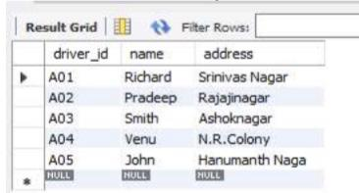

insert into car values('KA031181','Lancer',1957);

insert into car values('KA041702','Audi',2005);

insert into car values('KA052250','Indica',1990);

insert into car values('KA053408','Honda',2008);

insert into car values('KA095477','Toyota',1998);

commit;

select * from car;

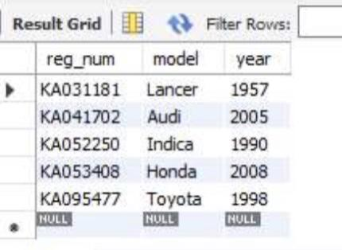

insert into accident values(11,'2003-01-01','Mysore Road');

insert into accident values(12,'2004-02-02','Southend Circle');

insert into accident values(13,'2003-01-21','Bulltemple Road');

insert into accident values(14,'2008-02-17','Mysore Road');

insert into accident values(15,'2005-03-04','Kanakpura Road');

commit;

select * from accident;

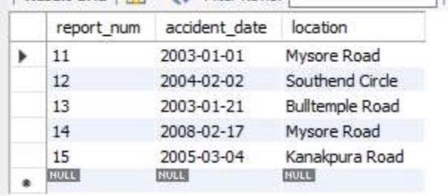

insert into owns values('A01','KA031181');

insert into owns values('A02','KA041702');

insert into owns values('A03','KA052250');

insert into owns values('A04','KA053408');

insert into owns values('A05','KA095477');

commit;

select * from owns;

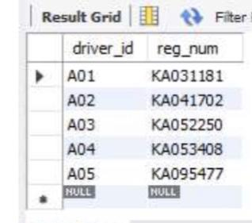

insert into participated values('A01','KA031181',11,10000);

insert into participated values('A02','KA041702',12,50000);

insert into participated values('A03','KA052250',13,25000);

insert into participated values('A04','KA053408',14,3000);

insert into participated values('A05','KA095477',15,5000);

commit;

select * from participated;

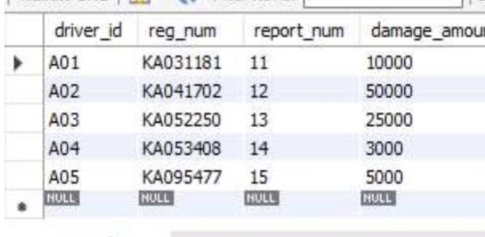

update participated set damage_amount=25000 where report_num=12;

insert into accident values(16,'2009-04-03','Kanakpura Road');

select * from accident;

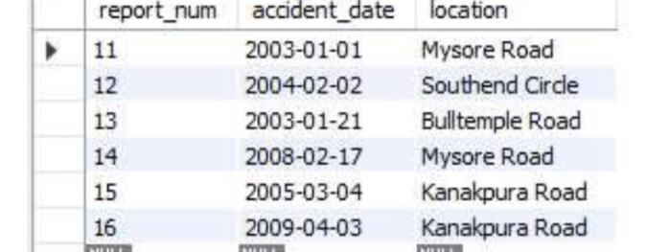

select count(*) from accident where year(accident_date)=2008;

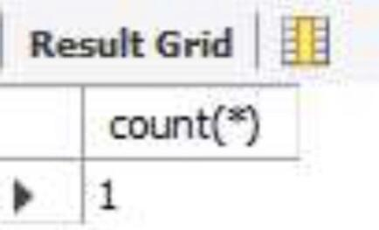

select count(report_num) CNT from car c,participated p where c.reg_num=p.reg_num and model='Lancer';

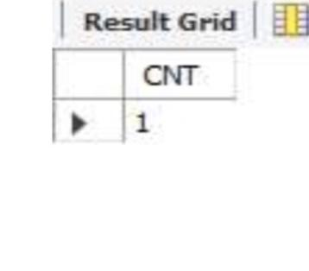

**LAB2-**

**BANKING ENTERPRISE DATABASE**

create database bank;

use bank;

create table branch (

branch_name varchar(25),

branch_city varchar(15),

assets int,

primary key (branch_name)

);

create table bank_account (

accno int,

branch_name varchar(25),

balance int,

primary key (accno),

foreign key (branch_name) references branch(branch_name)

);

create table bank_customer (

customer_name varchar(10),

customer_street varchar(25),

customer_city varchar(15),

primary key (customer_name)

);

create table depositer (

customer_name varchar(10),

accno int,

primary key(customer_name, accno),

foreign key (customer_name) references bank_customer(customer_name),

foreign key (accno) references bank_account(accno)

);

create table loan (

loan_number int,

branch_name varchar(25),

amount int,

primary key (loan_number),

foreign key (branch_name) references branch(branch_name)

);

insert into branch values('SBI_Chamrajpet', 'Bangalore', 50000);

insert into branch values('SBI_ResidencyRoad', 'Bangalore', 10000);

insert into branch values('SBI_ShivajiRoad', 'Bombay', 20000);

insert into branch values('SBI_ParliamentRoad', 'Delhi', 10000);

insert into branch values('SBI_Jantarmantar', 'Delhi', 20000);

commit;

select * from branch;

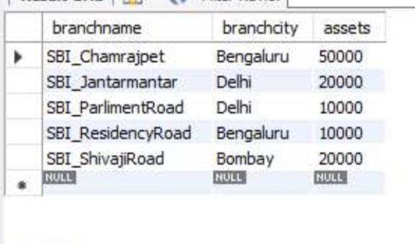

insert into bank_account values(1, 'SBI_Chamrajpet', 2000);

insert into bank_account values(2, 'SBI_ResidencyRoad', 5000);

insert into bank_account values(3, 'SBI_ShivajiRoad', 6000);

insert into bank_account values(4, 'SBI_ParliamentRoad', 9000);

insert into bank_account values(5, 'SBI_Jantarmantar', 8000);

insert into bank_account values(6, 'SBI_ShivajiRoad', 4000);

insert into bank_account values(8, 'SBI_ResidencyRoad', 4000);

insert into bank_account values(9, 'SBI_ParliamentRoad', 3000);

insert into bank_account values(10, 'SBI_ResidencyRoad', 5000);

insert into bank_account values(11, 'SBI_Jantarmantar', 2000);

commit;

select * from bank_account;

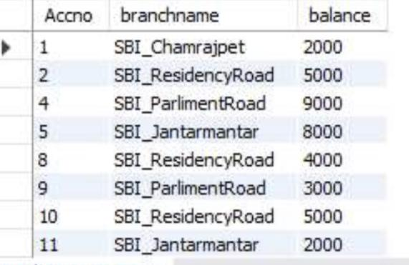

insert into bank_customer values ('Avinash', 'Bull_Temple_Road', 'Bangalore');

insert into bank_customer values ('Dinesh', 'Bannergatta_Road', 'Bangalore');

insert into bank_customer values ('Mohan', 'National_College_Road', 'Bangalore');

insert into bank_customer values ('Nikhil', 'Akbar_Road', 'Delhi');

insert into bank_customer values ('Ravi', 'Prithviraj_Road', 'Delhi');

commit;

select * from bank_customer;

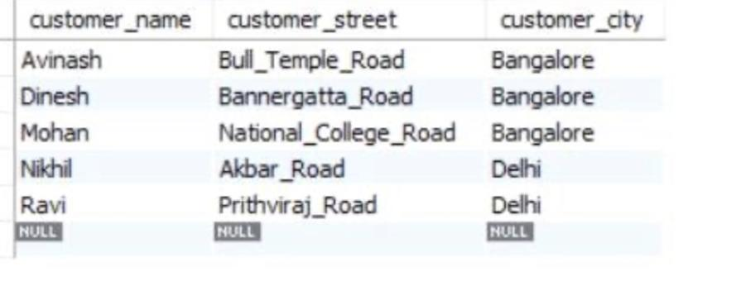

insert into depositer values('Avinash', 1);

insert into depositer values('Dinesh', 2);

insert into depositer values('Nikil', 4);

insert into depositer values('Ravi', 5);

insert into depositer values('Avinash', 8);

insert into depositer values('Nikil', 9);

insert into depositer values('Dinesh', 10);

insert into depositer values('Nikil', 11);

commit;

select * from depositer;

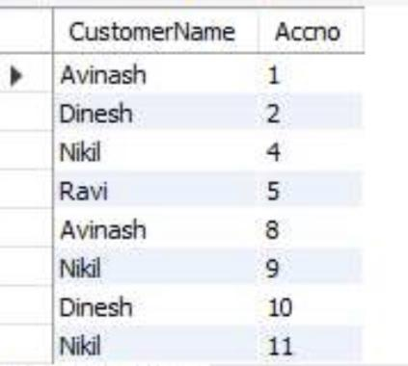

insert into loan values(1, 'SBI_Chamrajpet', 1000);

insert into loan values(2, 'SBI_ResidencyRoad', 2000);

insert into loan values(3, 'SBI_ShivajiRoad', 3000);

insert into loan values(4, 'SBI_ParliamentRoad', 4000);

insert into loan values(5, 'SBI_Jantarmantar', 5000);

commit;

select * from loan;

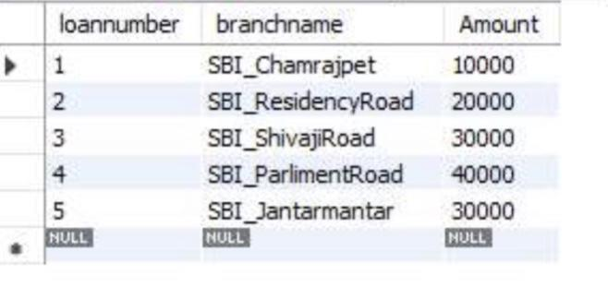

select distinct c.customer_name from bank_customer c,bank_account b where exists(select d.customer_name,count(d.customer_name) from depositer d,bank_account ba where ba.accno = d.accno and

c.customer_name = d.customer_name and ba.branch_name = 'SBI_ResidencyRoad' group by d.customer_name having count(d.customer_name)>=2);

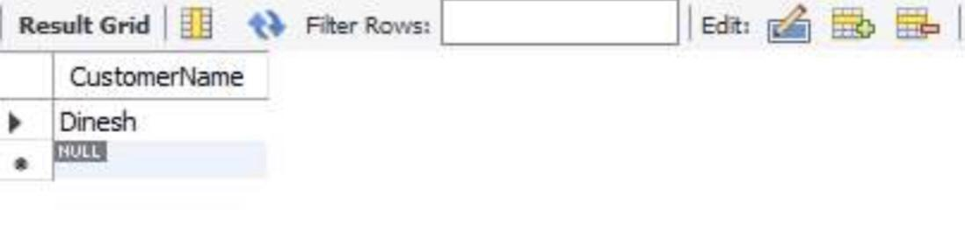

select distinct d.customer_name from depositer d where exists( select * from bank_account ba where ba.accno=d.accno and exists (select * from branch b where b.branch_name = ba.branch_name and b.branch_city='Delhi'));

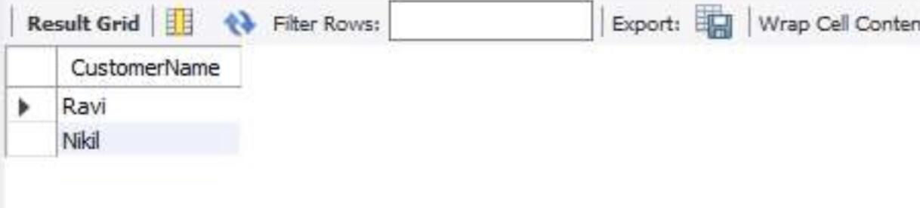

delete from bank_account where branch_name in (select branch_name from branch where branch_city = 'Bombay');

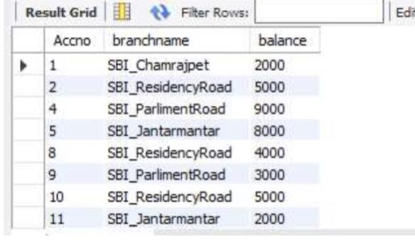

**LAB3-SUPPLIER DATABASE**

create database Supplier;

use Supplier;

create table Suppliers(

sid varchar(20) ,

sname varchar(20),

city varchar(20),

primary key(sid)

);

desc Suppliers;

create table Parts(

pid integer,

pname varchar(20),

color varchar(20),

primary key(pid)

);

desc Parts;

create table Catalog(

sid varchar(20),

pid integer,

cost real,

primary key(sid,pid),

foreign key(sid) references Suppliers(sid),

foreign key(pid) references Parts(pid)

);

desc Catalog;

insert into Suppliers values(10001,'Acme Widget','Bangalore');

insert into Suppliers values(10002,'Johns','Kolkata');

insert into Suppliers values(10003,'Vimal','Mumbai');

insert into Suppliers values(10004,'Reliance','Delhi');

insert into Suppliers values(10005,'Mahindra’,'Mumbai’);

select *from Suppliers;

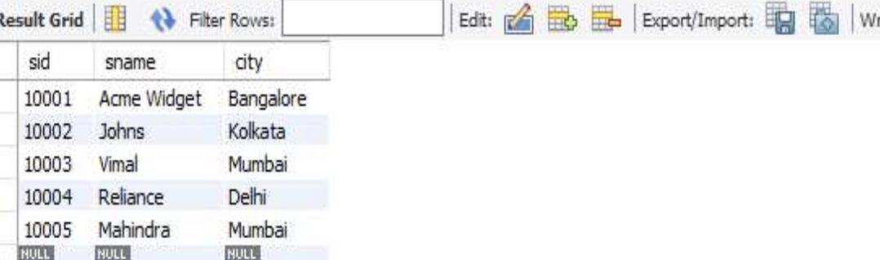

insert into Parts values(20001,'Book','Red');

insert into Parts values(20002,'Pen','Red');

insert into Parts values(20003,'Pencil','green');

insert into Parts values(20004,'Mobile','green');

insert into Parts values(20005,'Charger','Black');

select *from Parts;

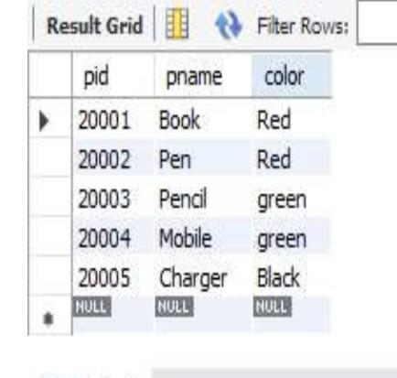

insert into Catalog values(10001,20001,10);

insert into Catalog values(10001,20002,10);

insert into Catalog values(10001,20003,30);

insert into Catalog values(10001,20004,10);

insert into Catalog values(10001,20005,10);

insert into Catalog values(10002,20001,10);

insert into Catalog values(10002,20002,20);

insert into Catalog values(10003,20003,30);

insert into Catalog values(10004,20003,40);

select *from Catalog;

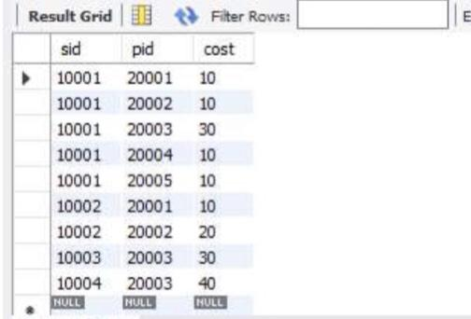

select distinct P.pname from Parts P, Catalog c where P.pid=C.pid;

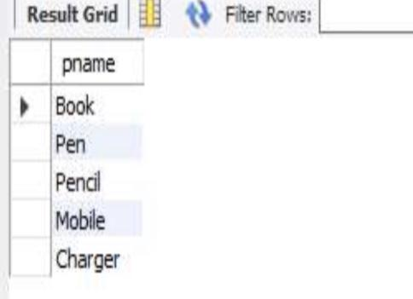

select S.sname from SUPPLIERS S where not exists (select P.pid from PARTS P where not exists (select C.sid from CATALOG C where C.sid = S.sid and C.pid = P.pid));

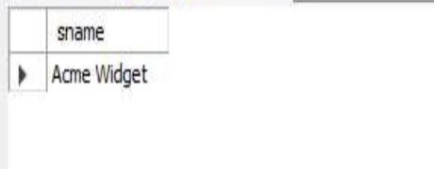

select S.sname from SUPPLIERS S where not exists (select P.pid from PARTS P where P.color = 'Red' and (not exists (select C.sid from CATALOG C where C.sid = S.sid and C.pid = P.pid)));

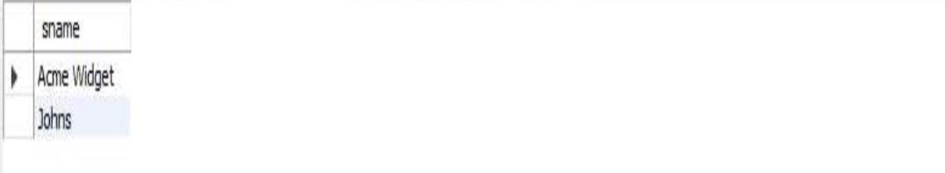

select P.pname from PARTS P, CATALOG C, SUPPLIERS S where P.pid = C.pid and C.sid = S.sid and S.sname = 'Acme Widget' and not exists (select * from CATALOG C1, SUPPLIERS S1 where P.pid = C1.pid and C1.sid = S1.sid and S1.sname <> 'Acme Widget');

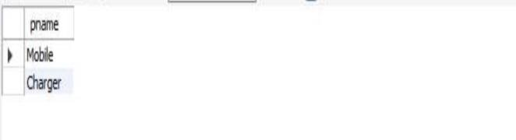

select distinct c.sid from Catalog c where c.cost >(select avg(ca.cost) from Catalog ca where ca.pid=c.pid);

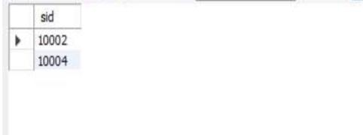

select s.sname ,p.pid from Suppliers s, Catalog c, Parts p where s.sid=c.sid and c.pid =p.pid and c.cost=(select max(ca.cost) from catalog ca where ca.pid=p.pid);

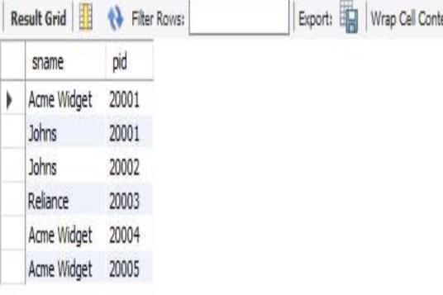

**LAB4-**

**STUDENT FACULTY DATABASE**

create database student_faculty;

use student_faculty;

create table student(snum int, sname varchar(10), major varchar(2), lvl varchar(2), age int,primary key (snum));

desc student;

create table faculty(fid int, fname varchar(20), deptid int,primary key(fid));

desc faculty;

create table class(cname varchar(20), meetsat timestamp, room varchar(10), fid int,primary key (cname),foreign key(fid) references faculty(fid));

desc class;

create table enrolled(snum int, cname varchar(20),primary key(snum,cname),

foreign key(snum) references student(snum),

foreign key(cname) references class(cname));

desc enrolled;

insert into student values(1, 'jhon', 'CS', 'Sr', 19);

insert into student values(2, 'Smith', 'CS', 'Jr', 20);

insert into student values(3 , 'Jacob', 'CV', 'Sr', 20);

insert into student values(4, 'Tom ', 'CS', 'Jr', 20);

insert into student values(5, 'Rahul', 'CS', 'Jr', 20);

insert into student values(6, 'Rita', 'CS', 'Sr', 21);

select * from student;

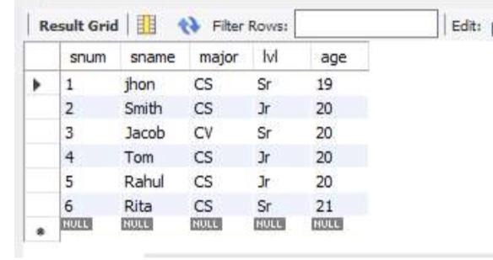

insert into faculty values(11, 'Harish', 1000);

insert into faculty values(12, 'MV', 1000);

insert into faculty values(13 , 'Mira', 1001);

insert into faculty values(14, 'Shiva', 1002);

insert into faculty values(15, 'Nupur', 1000);

select * from faculty;

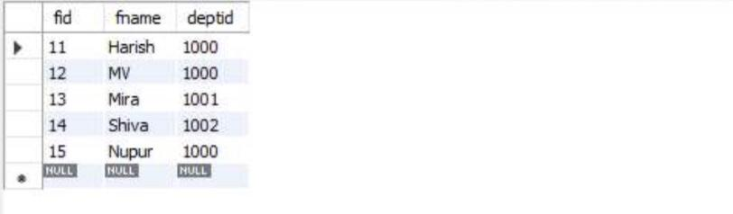

insert into class values('class1', '12/11/15 10:15:16', 'R1', 14);

insert into class values('class10', '12/11/15 10:15:16', 'R128', 14);

insert into class values('class2', '12/11/15 10:15:20', 'R2', 12);

insert into class values('class3', '12/11/15 10:15:25', 'R3', 12);

insert into class values('class4', '12/11/15 20:15:20', 'R4', 14);

insert into class values('class5', '12/11/15 20:15:20', 'R3', 15);

insert into class values('class6', '12/11/15 13:20:20', 'R2', 14);

insert into class values('class7', '12/11/15 10:10:10', 'R3', 14);

select * from class;

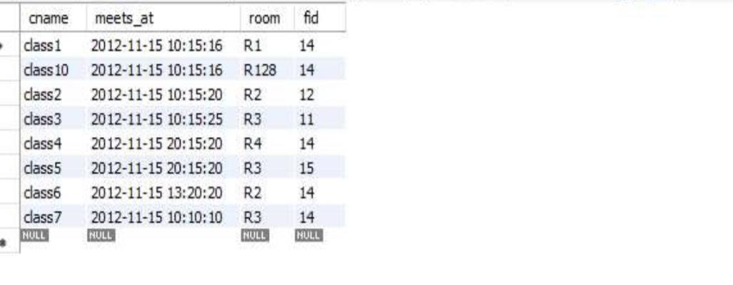

insert into enrolled values(1, 'class1');

insert into enrolled values(2, 'class1');

insert into enrolled values(3, 'class3');

insert into enrolled values(4, 'class3');

insert into enrolled values(5, 'class4');

insert into enrolled values(1, 'class5');

insert into enrolled values(2, 'class5');

insert into enrolled values(3, 'class5');

insert into enrolled values(4, 'class5');

insert into enrolled values(5, 'class5');

select * from enrolled;

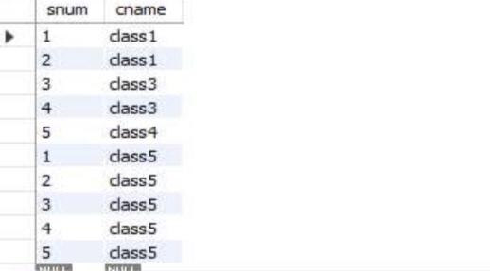

SELECT DISTINCT S.sname

FROM student S, class C, enrolled E, faculty F

WHERE S.snum = E.snum AND E.cname = C.cname AND C.fid = F.fid AND

F.fname = 'Harish' AND S.lvl = 'Jr';

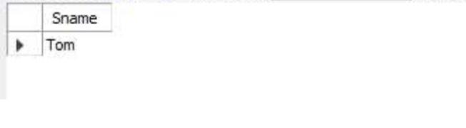

SELECT C.cname

FROM class C

WHERE C.room = 'R128'

OR C.cname IN (SELECT E.cname

FROM enrolled E

GROUP BY E.cname

HAVING COUNT(*) >= 5);

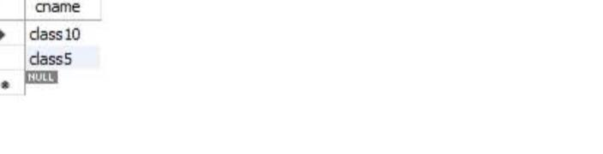

SELECT DISTINCT S.sname

FROM student S

WHERE S.snum IN (SELECT E1.snum

FROM enrolled E1, enrolled E2, class C1, class C2

WHERE E1.snum = E2.snum AND E1.cname <> E2.cname

AND E1.cname = C1.cname

AND E2.cname = C2.cname AND C1.meets_at = C2.meets_at);

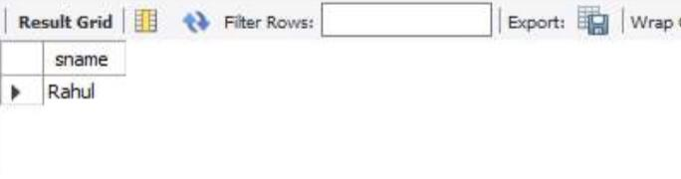

SELECT f.fname,f.fid

FROM faculty f

WHERE f.fid in ( SELECT fid FROM class

GROUP BY fid HAVING COUNT(*)=(SELECT COUNT(DISTINCT room) FROM class));

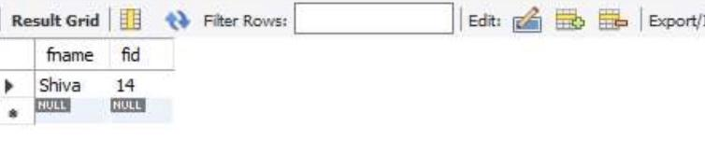

SELECT DISTINCT F.fname

FROM faculty F

WHERE 5 > (SELECT COUNT(E.snum)

FROM class C, enrolled E

WHERE C.cname = E.cname

AND C.fid = F.fid);

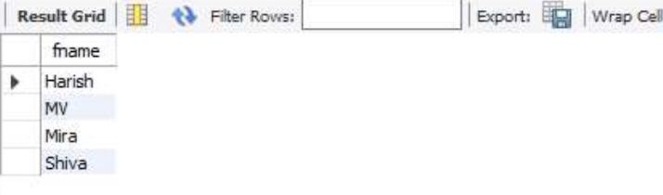

SELECT DISTINCT S.sname

FROM student S

WHERE S.snum NOT IN (SELECT E.snum

FROM enrolled E );

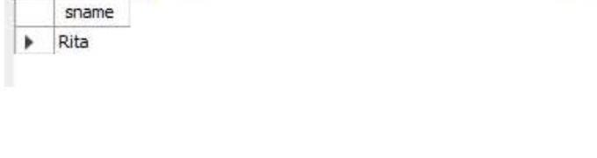

SELECT S.age, S.lvl

FROM Student S

GROUP BY S.age, S.lvl

HAVING S.lvl IN (SELECT S1.lvl FROM Student S1

WHERE S1.age = S.age

GROUP BY S1.lvl, S1.age

HAVING COUNT(*) >= ALL (SELECT COUNT(*)

FROM Student S2

WHERE s1.age = S2.age

GROUP BY S2.lvl, S2.age));

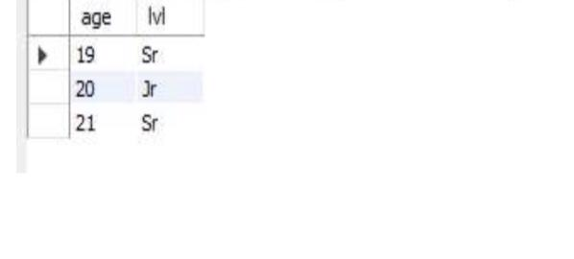

**LAB5-AIRLINE FLIGHT DATABASE**

create database Airline_flight;

use Airline_flight;

create table flights(

flno int,

fromplace varchar(15),

toplace varchar(15),

distance int,

departs datetime,

arrives datetime,

price int,

primary key (flno));

desc flights;

create table aircraft(

aid int,

aname varchar(15),

cruisingrange int,

primary key (aid));

desc aircraft;

create table employees (

eid int,

ename varchar(15),

salary int,

primary key (eid));

desc employees;

create table certified (

eid int,

aid int,

foreign key (eid) references employees(eid),

foreign key (aid) references aircraft(aid));

desc certified;

insert into flights values(101, 'Bangalore', 'Delhi', 2500, '2005-05-13 07:15:31', '2005-05-13 18:15:31', 5000);

insert into flights values(102, 'Bangalore', 'Lucknow', 3000, '2013-05-05 07:15:31', '2013-05-05 11:15:31', 6000);

insert into flights values(103, 'Lucknow', 'Delhi', 500, '2013-05-05 12:15:31', '2013-05-05 17:15:31', 3000);

insert into flights values(107, 'Bangalore', 'Frankfurt', 8000, '2013-05-05 07:15:31', '2013-05-05 22:15:31', 60000);

insert into flights values(104, 'Bangalore', 'Frankfurt', 8500, '2013-05-05 07:15:31', '2013-05-05 23:15:31', 75000);

insert into flights values(105, 'Kolkata', 'Delhi', 3400, '2013-05-05 07:15:31', '2013-05-05 09:15:31', 7000);

insert into flights values(106, 'Bangalore', 'Kolkata', 1000, '2013-05-05 01:15:30', '2013-05-05 09:20:30', 10000);

insert into flights values(108, 'Lucknow', 'Kolkata', 1000, '2013-05-05 11:30:30', '2013-05-05 15:20:30', 10000);

select * from flights;

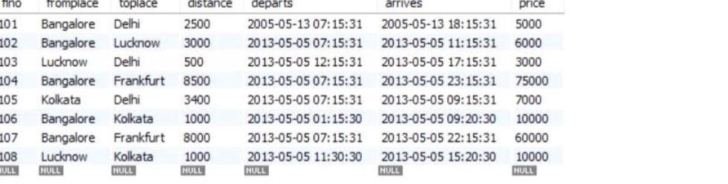

insert into aircraft values(101, '747', 3000);

insert into aircraft values(102, 'Boeing', 900);

insert into aircraft values(103, '647', 800);

insert into aircraft values(104, 'Dreamliner', 10000);

insert into aircraft values(105, 'Boeing', 3500);

insert into aircraft values(106, '707', 1500);

insert into aircraft values(107, 'Dream', 120000);

insert into aircraft values(108, '707', 760);

insert into aircraft values(109, '747', 1000);

select * from aircraft;

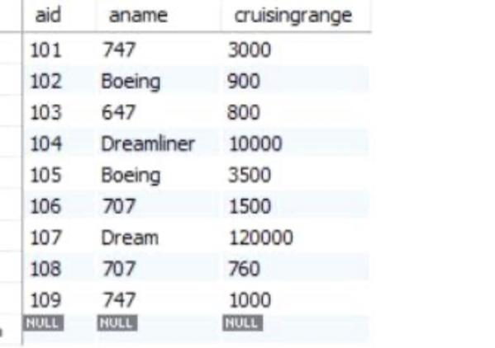

insert into employees values(701, 'A', 50000);

insert into employees values(702, 'B', 100000);

insert into employees values(703, 'C', 150000);

insert into employees values(704, 'D', 90000);

insert into employees values(705, 'E', 40000);

insert into employees values(706, 'F', 60000);

insert into employees values(707, 'G', 90000);

select * from employees;

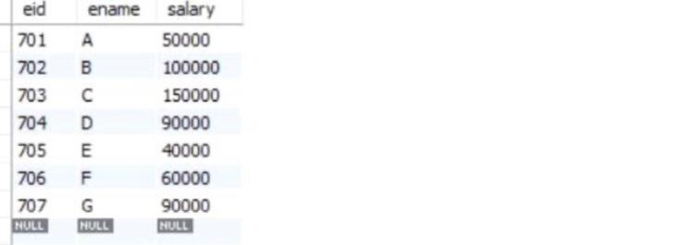

insert into certified values(701, 101);

insert into certified values(701, 102);

insert into certified values(701, 106);

insert into certified values(701, 105);

insert into certified values(702, 104);

insert into certified values(703, 104);

insert into certified values(704, 104);

insert into certified values(702, 107);

insert into certified values(703, 107);

insert into certified values(704, 107);

insert into certified values(702, 101);

insert into certified values(702, 108);

insert into certified values(701, 109);

select * from certified;

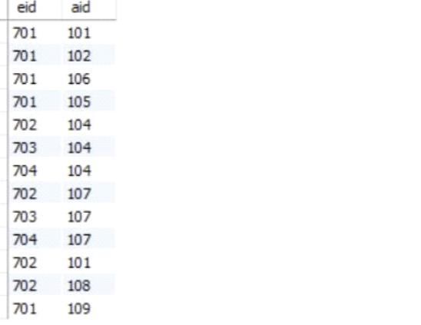

select distinct a.aname from aircraft a where a.aid in (

select c.aid from certified c, employees e where

c.eid = e.eid and not exists(

select * from employees e1 where e1.eid=e.eid and e1.salary<80000));

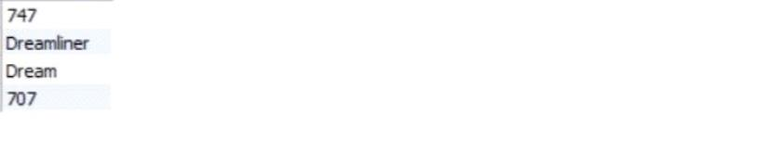

select max(a.cruisingrange), c.eid from certified c, aircraft a

where c.aid = a.aid group by c.eid having count(c.eid)>3;

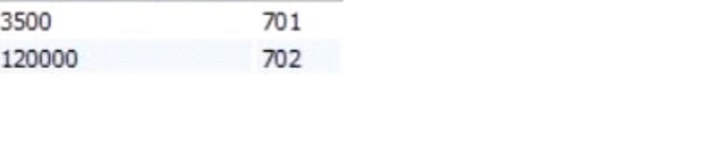

select ename from employees where salary <(

select min(price) from flights where fromplace='Bangalore' and toplace='Frankfurt');

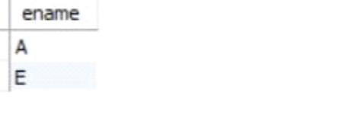

select avg(e.salary), c.aid from certified c, employees e where c.aid in(

select aid from aircraft where cruisingrange>1000) and e.eid = c.eid group by c.aid;

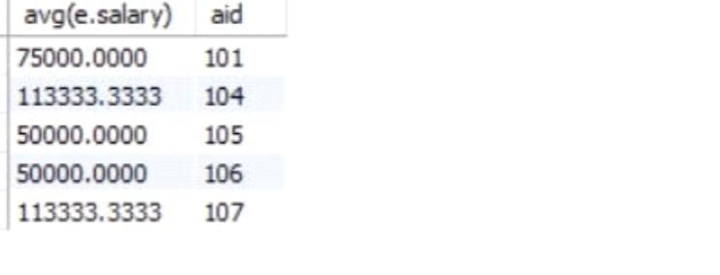

select ename from employees where eid in(

select eid from certified where aid in(

select aid from aircraft where aname = 'Boeing'));

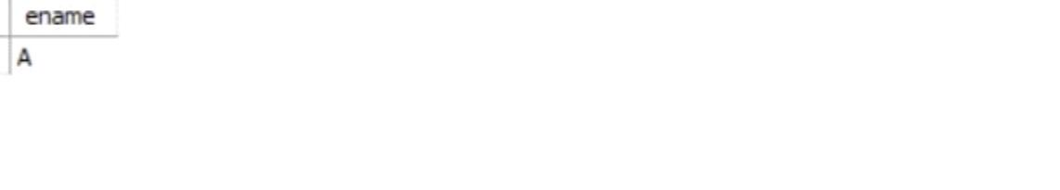

select aname from aircraft where cruisingrange > any

(select distance from flights where fromplace='Bangalore' and toplace='Delhi');

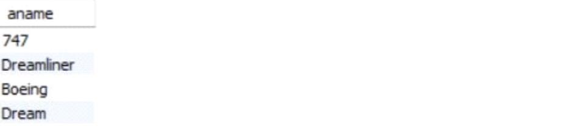

select F.flno, F.departs

from flights F

Where F.flno in ( ( select F0.flno

from flights F0

where F0.fromplace = 'Bangalore' and F0.toplace = 'Kolkata'

and extract(hour from F0.arrives) < 18 )

union

( select F0.flno

from flights F0, flights F1

where F0.fromplace = 'Bangalore' and F0.toplace <> 'Kolkata'

and F0.toplace = F1.fromplace and F1.toplace = 'Kolkata'

and F1.departs > F0.arrives

and extract(hour from F1.arrives) < 18)

union

( select F0.flno

from flights F0, flights F1, flights F2

where F0.fromplace = 'Bangalore'

and F0.toplace = F1.fromplace

and F1.toplace = F2.fromplace

and F2.toplace = 'Kolkata'

and F0.toplace <> 'Kolkata'

and F1.toplace <> 'Kolkata'

and F1.departs > F0.arrives

and F2.departs > F1.arrives

and extract(hour from F2.arrives) < 18));

